**PART 1 – ESTUARY ECOLOGY**

**Estuaries**

* 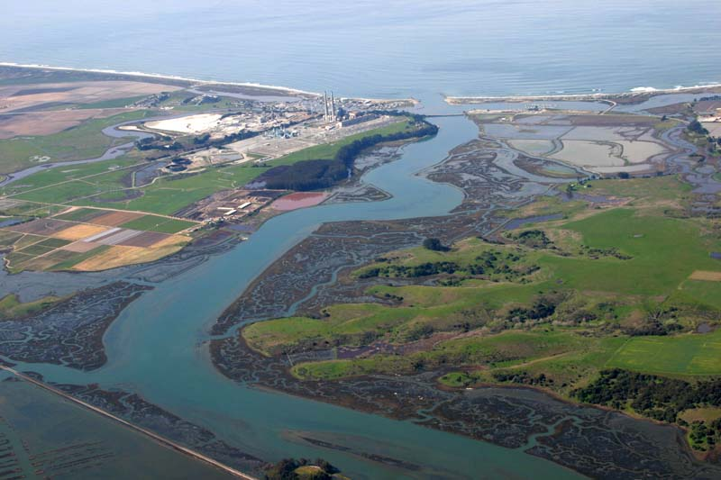An *estuary* is the areas of water and shoreline where a freshwater stream or river merges with the ocean
* **Estuaries can be partially enclosed body of water (such as bays, lagoons, sounds or sloughs) where two different bodies of water meet and mix**
* They often bordered by salt marshes or intertidal mudflats
* Salinity varies within the estuary from nearly fresh water to ocean water
* It also varies daily in these areas due to rise and fall of tides
* They are very productive due to nutrients brought in by rivers
* A unique combination of salt and fresh water creates a variety of habitats in which the plants and animals survive in various brackish water combinations
* Estuaries have a diverse flora and fauna and tremendous productivity
  + Salt marsh grasses, algae, and phytoplankton are the major producers
  + Many species of annelids, oysters, crabs, and fish are present
  + Many marine invertebrates and fish breed in estuaries or migrate through themtofreshwater habitats upstream
  + A large number of water fowl and other semi-aquatic vertebrates use estuaries as feeding areas
* Human activities are having a large impact on estuaries
  + Estuaries receive the pollutants dumped into the streams and rivers that feed them
  + Residential and commercial development not only adds to pollution but eliminates some estuaries due to land filling
* Freshwater from rivers sometimes mixes with large freshwater bodies as the Great Lakes creating a "freshwater estuary" that functions like typical brackish estuaries

**Estuary Classification by Water Circulation**: - salt-wedge, fjord, slightly stratified, vertically mixed, freshwater – The amount of circulation affects the salt distribution and salinity concentrations

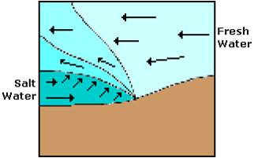***Salt-Wedge Estuaries***

* Salt wedge estuaries occur when the mouth of a river flows directly into salt water.
* The mouths of the Mississippi, Columbia and Hudson rivers are examples of salt wedge estuaries
* The water circulation is controlled by the river that pushes back the seawater.
* This circulation creates a sharp boundary that separates an upper less salty layer from an intruding wedge-shaped salty bottom layer.

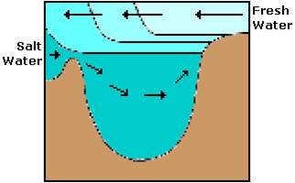***Fjord***

* Fjord type estuaries are characterized by a deep elongated basin that is U-shaped and a ledge or barrier that separates the basin from the sea.
* Fjord type estuaries are found along glaciated coasts such as British Columbia, Alaska, Chile, New Zealand, and the Scandinavian countries
* They have moderately high river input and little tidal mixing.

***Slightly Stratified or Partially Mixed Estuary***

* 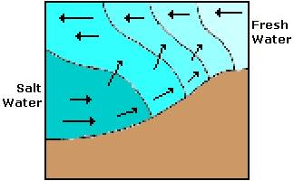Partially mixed estuaries have a tidal flow that provides a means of erasing the salt wedge.
* Deeper estuaries such as Puget Sound and San Francisco Bay are examples of partially mixed estuaries
* The salt water is mixed upward and fresh water is mixed downward.
* The lower layers of water typically remain saltier than the upper layers

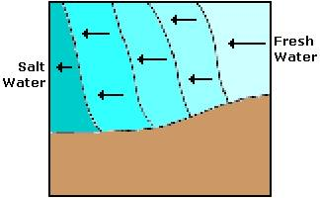***Vertically Stratified or Well Mixed Estuaries***

* Well-mixed estuaries have strong tidal mixing and low river flow that mix the sea water throughout the shallow estuary.
* Shallow estuaries such as the Delaware Bay are well-mixed estuaries
* The mixing is so complete that the salinity is the same top to bottom and decreases from the ocean to the river.

***Freshwater Estuaries***

* Freshwater estuaries occur where massive freshwater systems, as the Great Lakes, are diluted by river or stream waters draining from adjacent lands
* Freshwater estuaries do not contain saltwater, but they are unique combinations of river and lake water, which are chemically distinct
* freshwater estuaries are storm-driven while brackish estuaries that are tidally driven
* 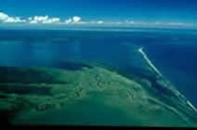Storm surges and subsequent seiches (vertical oscillations, or sloshing, of lake water) regulate the composition of the estuary water
* Though the Great Lakes do exhibit small tides, Seiches acting like tides, exchanging water between the river and the lake
* Changes in temperature differences between stream water and lake waters can cause stratification and mixing of the water
* Shallow waters of streams respond more quickly to changes in temperature changes than deeper lake waters influencing the chemistry such as its salinity, dissolved oxygen, and pH the of the water of the river and the large lake Lake Superior Estuary

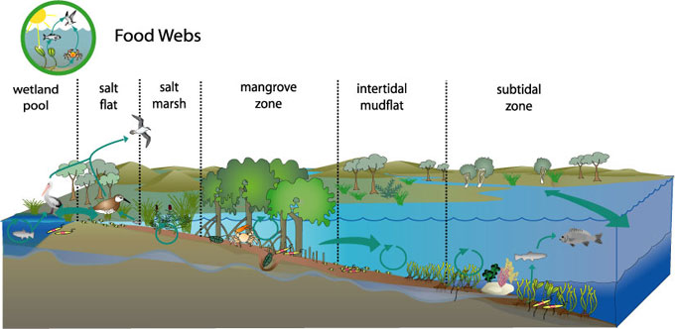**Common Estuarine Habitats:**

* oyster reefs
* kelp forests
* rocky and soft shorelines
* submerged aquatic vegetation
* coastal marshes
* mangroves forests
* mud flats
* tidal streams
* barrier beaches
* salt marshes
* deepwater swamps and riverine forests

**Food Webs and Adaptations in an Estuary**

**Special Adaptations of their Organisms**

* Estuaries can contain several types of habitats that determine the types of organisms that can survive
* Salinity, temperature, water levels and light levels vary along the length of an estuary
* Organic accumulation is common
* Irregular surfaces and high energy wind patterns and waves along with tidal action require strong root systems for plants and methods for dealing with intermittent wet and dry conditions
* These conditions require **special adaptations** to survive
* Many of the species can live in one or more the estuary environments because their characteristics stress the organisms in similar ways
* Coping mechanisms include moving out of unfavorable areas, shutting up shells, digging borrows and excretion of excess salts
* Many fish maintain water balance by actively drinking salt water, from which much of the water is absorbed by the gut and the solutes are excreted through the gills and the kidneys
* Fish also adapt by increasing their respiratory water flow and increase oxygen consumption to compensate for the depressing effects of low temperatures
* Organisms have mechanisms to deal with high energy winds and waves
* The most efficient tree is low, with numerous crowded branches
* Other adaptations of the tree may include flattening of the trunk, root and branches in a plan parallel to the wind direction

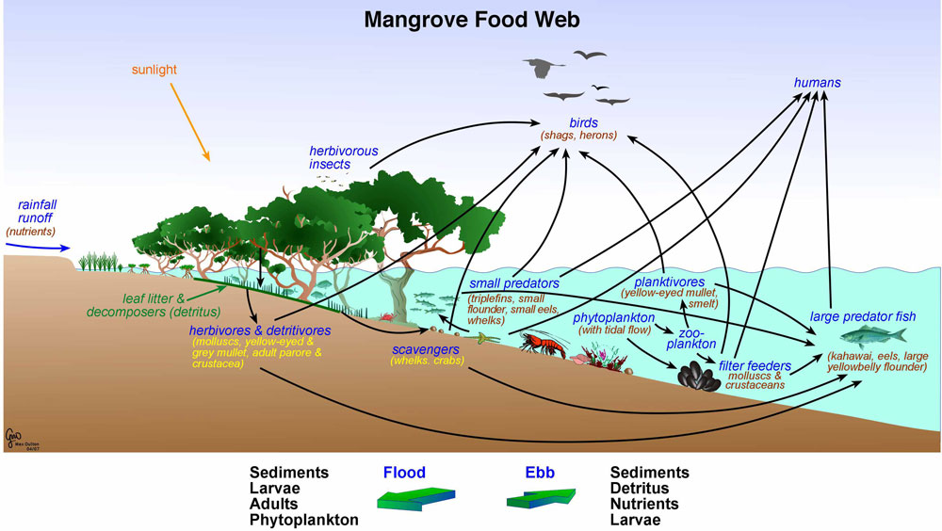

**Estuary Food Web**

* Estuaries are areas of great diversity, with complex and interrelated trophic patterns and they support a large number of top predators, including humans
* Unlike the open ocean, where phytoplankton are the sole primary

producers, estuarine systems usually contain **several types of primary producers**.

* **Primary producers** include phytoplankton, algae, sea grasses, and salt-marsh plants. **Larger estuarine plants** serve as food for some grazing aquatic animals but are more important food sources after they die and begin to decompose
* **Zooplankton** graze on phytoplankton and become food for the carnivores plankton-eating fishes, such as small fish, and larvae and young of larger fishes. and omnivores
* Estuaries are **nurseries of the sea** because juvenile forms of many marine animals live and feed in estuaries before returning to the sea
* Bacteria and fungi promote the breakdown of the dead material organic detritus- an essential source of nutrition for detritus-eating animals and supports a detrital food web.
* **Benthic, or bottom-dwelling, and bottom-oriented organisms** are other important links in estuarine food chains and webs. Clams, for example, reside in the bottom sediments and feed on plankton and other organic matter by filtering it from the water. Oysters and mussels are other filter feeders.
* **Deposit feeders**, such as the various kinds of worms found in the estuary, move over and through bottom sediments where they find food deposited in or on the sediments.
* Shrimps, crabs, and other invertebrates are well adapted to bottom feeding, as are many of the estuarine fishes - most fish species that live in estuaries or move into them on for feeding are bottom oriented in their feeding patterns.
* 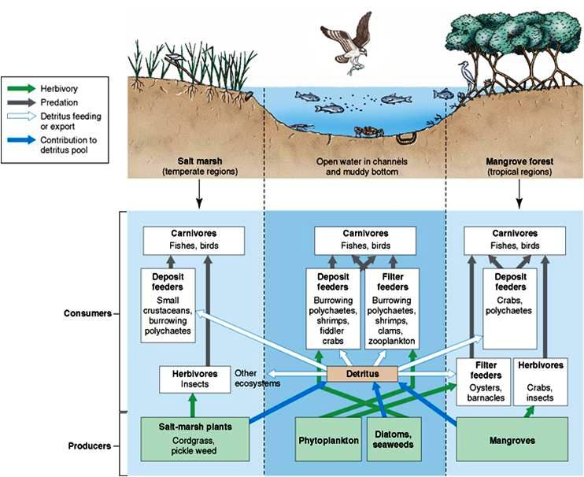Near the top of the estuarine food web are various carnivores and omnivores. Some have food preferences and others are opportunistic feeders. These are the fishes and birds as well as human

**Characteristics of Common Estuarine Habitats:**

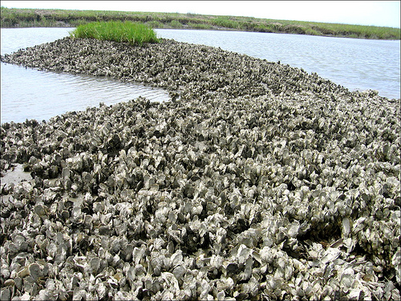***Oyster Reefs***

* Oyster reefs - common submerged habitats near shore areas and estuaries,
* They grow especially vigorously near river mouths where waters are brackish and less than 10 meters deep.
* Oysters reproduce and settle on the shells of other oysters and
* Over time, the oysters may form massive reef structures consisting of staggering numbers of individuals.
* These reefs are host to several species of breeding fish, smaller organisms and snails often forming a complete microhabitat.

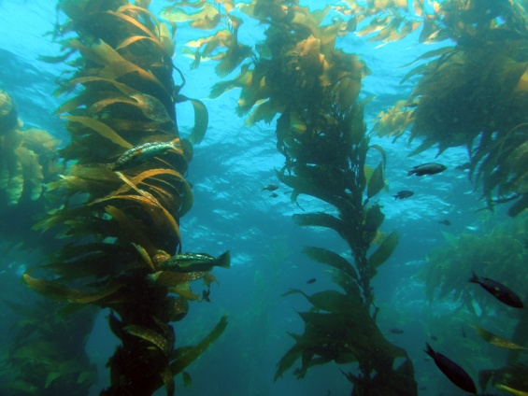***Kelp Forests***

* Kelp Forests occur in cold, nutrient-rich water of shallow open coastal waters
* Dependence upon light for photosynthesis restricts them to clear shallow water
* They are rarely much deeper than 15-40 m
* Kelp plants attach to the rocky bottom with tough holdfasts and grow up towards the surface on strong flexible stipes that are buoyed by gas bladders.
* When the fast growing fronds reach the surface, they spread horizontally to form the kelp forest canopy – some species can grow 30 cm per day
* Kelp forests are very productive and support areas of high plant biomass
* 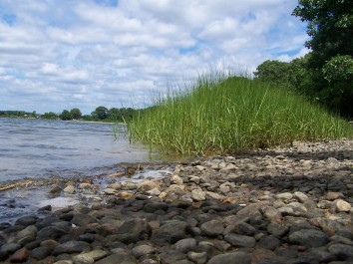They are rich in animal species

***Rocky Shorelines and Bottoms***

* Rocky shores and bottoms have hard surfaces made of stones, boulders and bedrock.
* These habitats are found along our west and northeast coasts
* They deal with may have high waves and strong high energy winds
* Flooding occurs only when the tide goes out

***Soft Shores and Bottoms***

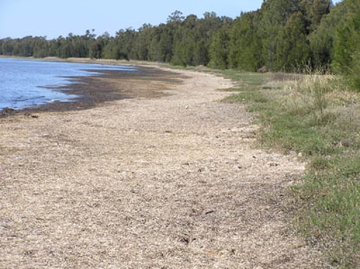

* Soft shores and bottoms are low-lying sand beaches, muddy shores and mudflats made of sediments that have mixed with detritus (think of muck or ooze).
* Soft shore and bottom habitats are found along coasts across the country
* Some contain submerged and upland vegetation, some do not.
* Many different benthic communities or bottom dwellers flourish in the soft shores and bottoms including burrowing worms, snails, crabs and clams

*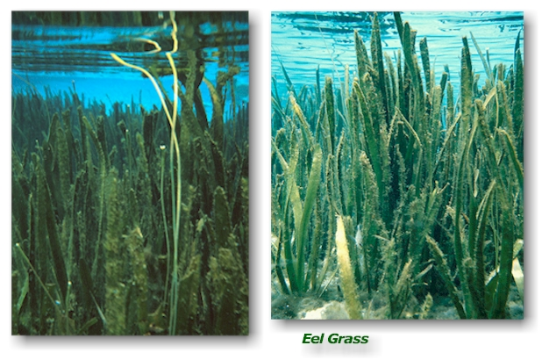****Submerged Aquatic Vegetation***

* Submerged aquatic vegetation, also called SAV, are beds of leafy rooted, grass-like plants with tiny flowers, found in shallow waters where light can penetrate.
* SAV is found along coasts across the county
* They survive underwater [subtidal](http://estuaries.noaa.gov/Resources/Default.aspx?ID=136) areas or in areas that are both flooded and partially exposed by the tides (intertidal areas)

*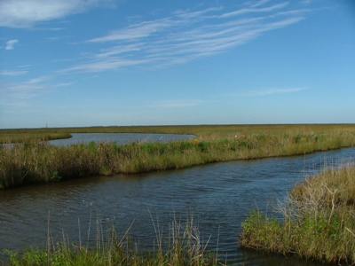****Coastal Marshes***

* Coastal marshes are composed of upright plants that live above the water surface, often with their roots submerged
* Coastal marshes are found across the county
* Some examples of coastal marsh plats are cattails, grasses, and sedges

***Mangroves or Mangrove Forests***

* 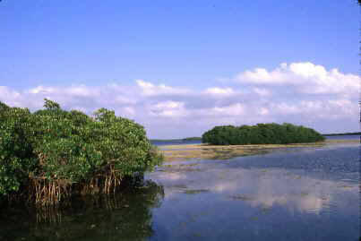Various kinds of trees up to medium height and shrubs that grow in saline coastal sediment habitats in the tropics and subtropics
* Mangroves are trees that can survive in very salty areas
* These forests grow along the coasts of the Gulf of Mexico and in the Caribbean
* Mangroves grow in clusters and their roots form a complex maze along the base of the trees
* They are commonly identified by their unique roots which project from the muddy bottoms at the shore to the tree’s trunk coast

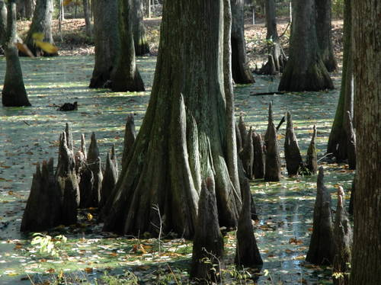***Deepwater Swamps and Riverine Forests***

* Deepwater swamps and riverine forests are flooded, forested wetlands growing near edges of lakes, rivers and sluggish streams.
* Deepwater coastal swamps and riverine forests are found across the country,
* They are most common along the Atlantic and Gulf Coasts and throughout the Mississippi River valley
* They are different from other forests because they can survive in areas with prolonged flooding

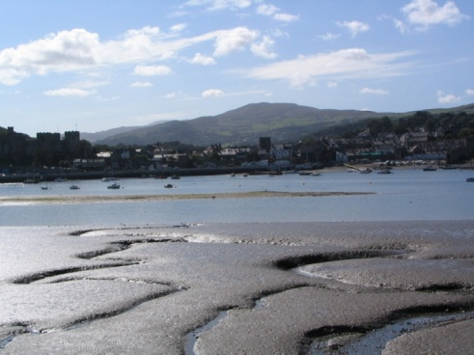

***Mud Flats and Sand Flats***

* Mudflats arepart of benthic (bottom) zone exposed at low tide and comprised of extremely fine sediments
* Sand flats area of bottom of aquatic system that is exposed by low tides and composed of sand - particles of sediment larger than those of mudflats
* Mudflat characteristics are defined by their specific combination of sand, silt, clay and organic matter content
* Organisms best suited for the mud flat are burrowers
* Mudflats are exposed during low tides, leaving non-burrowing species open to predation.

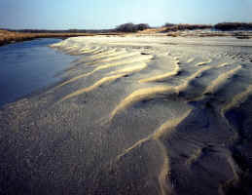***Tidal Streams***

* Tidal streams are highly productive transitional areas between the freshwater of rivers and the salt water of bays.
* Tidal streams serve as nurseries for many fish and shellfish, including several species important for commerce and recreation.
* Many macroinvertebrates are often present

***Barrier Beaches***

* 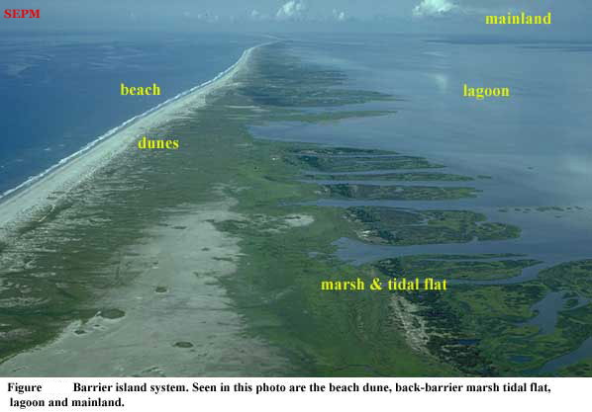Barrier Beaches are spits of sand that form parallel to the shore
* Pounding waves, shifting sands, strong winds, and saline soils make living on the beach difficult
* Microscopic and larger animals have adapted to life under the sand to escape the harsh conditions

at the surface by burrowing into the sand

* Low, sprawling root systems helphold the plants in place as winds blow and sands shift
* Thick leathery or hairy leaves help reduce water loss.

***Salt Marshes***

* Salt marsh arewetland flooded regularly by tidal, brackish water
* Sediment in the salt marsh often has a high salt content
* Salt marsh organisms must be able to access fresh water
* Salinity levels in the salt marsh vary as river inflow and tidal inflow compete
* Tangled marsh plant roots help to stabilize the muddy bottom of the marsh and trap debris and nutrient with the tides so the soil is organically rich in nutrients and highly productive
* **Salt pannes and pools** are water retaining depressions located within salt and brackish marshes. Pools tend to retain water during the summer months between high tides

**Low tide High tide**

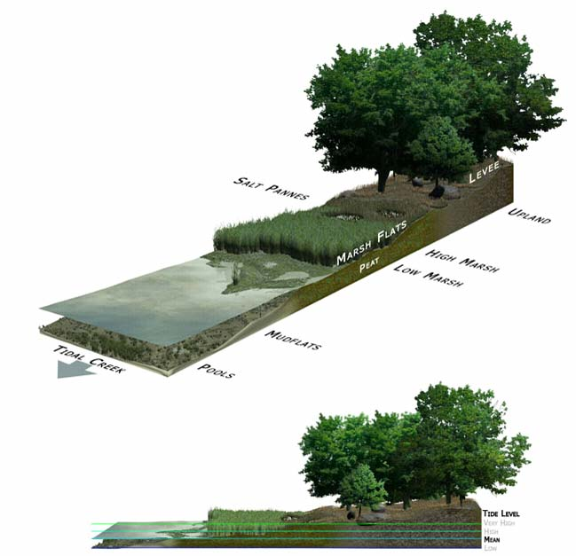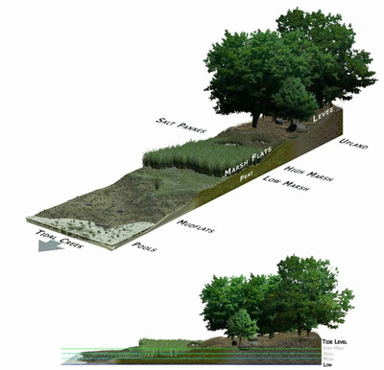

**Importance of Estuaries**

* Of the 32 largest cities in the world, 22 are located on estuaries
* Many animal species rely on estuaries for nesting and breeding
* Most of the fish and shellfish eaten in the United States, including salmon, herring, and oysters, complete at least part of their life cycles in estuaries
* Estuaries filter out sediments and pollutants from rivers and streams before they flow into the ocean, providing cleaner waters for humans and marine life
* Humans also rely on estuaries for recreation, jobs, and even our homes
* Coastal development, introduction of invasive species, over fishing, dams, and global climate change have led to a decline in the health of estuaries, making them one of the most threatened ecosystems on Earth.

**Invasive Species**

|  |
| --- |
| * Invasive species are those that do not naturally live in an estuary, but were introduced,   often accidentally, by humans   * Invasive species compete with native plants and animals for shelter and food and weaken   the ecosystem   * Examples of estuarine invasive species include   *Plants* - Eurasian watermilfoil, hydrilla, purple loosestrife,  *Animals* - Asian carp, Chinese mitten crab, European green crab, lionfish, northern snakehead,  and zebra mussel. |

**POINT AND NON-POINT SOURCE POLLUTION:**

* Pollutants pose a large threat to estuarine organisms
* Pollutants are introduced into estuaries from either point sources or non-point sources.
  + **Point sources** are clearly defined, localized inputs such as pipes, industrial plants, sewer systems, oil spills from tankers, and aquaculture ventures.

The federal and state governments regulate them.

* + **Non-point sources** are indistinct inputs that do not have a clearly defined

source, such as runoff of petroleum products from roadways or pesticides

from farmland.

* + A majority of pollutants find their way into estuaries from non-point sources
  + Non-point sources are harder to detect and control
  + Reduction of pollution requires substantial individual and collective efforts

**Estuary Preservation**

* Ensuring the health of our estuaries is vital to the survival of the plant and animal communities that call them home and the humans that depend on them for their way of life.
* To preserve our estuaries, the **National Estuarine Research Reserve System** was established to protect more than 1.3 million acres of estuarine habitat for long-term research, monitoring, education, and stewardship throughout the coastal United States.

Important Resources: Educational Resources on the NOAA, and EPA websites

ESTUARY-NET A Water Quality Monitoring Project